|  |  |
| --- | --- |
| E:\Users\bergg\Documents\My Templates\Word\Accountancy\Accountancy\Accountancy_color_h.png | **5320 Memorandum** |

To: 5320 Students

From: Gary G. Berg

Date: September 10, 2024

Re: Assignment 2

* Download the Access file on the class web site. (You will need to create the relationships between tables enforcing referential integrity to do this assignment)
* This is an assignment uses SQL to create the practice queries in Access from the database for the Appendix D from the textbook.

**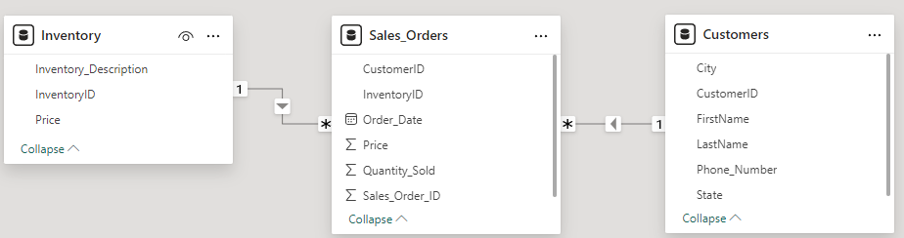**

* There will be a total of 16 queries to be created.
  + Use of QBE as a last resort.
    - If you are at an organization using databases such as SAP, Oracle, or other similar relational databases, you will need to have a basic understanding of SQL in order to extract the data you need. QBE will not be an option.
  + Practice queries (name as indicated below)
    - Page 547 - 3 queries (select from practice) S1 – S3
      * In addition, S2 should include customer first name and last name **(master the data**
      * In addition, S3 should include customer first name and last name
    - Page 550 - 5 queries (select from where practice) W1 – W5
    - Page 553 - 2 queries (aggregates and aliases practice) A1 – A 2
    - Page 555 – 2 queries (group by practice) GB1 – GB2
    - Page 556 – 2 queries (having practice) HP1 – HP2
    - Page 558 – 2 queries (inner join practice) J1 – J2
* **This assignment is not a group project. Students should work independently**.
  + **Copying/plagiarism** will result in a **grade of 0** for all parties involved.
* **Make sure you submit the Access file and not the temp file. Submission of the temp file will result in a grade of ZERO**
  + The temp file is a 1kb file created while you work with the Access database file. When you exit the database, the temp file should be deleted, but on some occasions, it is not deleted.
  + Check the file size of your D2L submission. If it is 1kb, you have submitted the temp file. Your submitted file will probably be around 850kb to 900 kb.
* Make sure file is **Virus free**.
  + Any file received with a virus will receive a **grade of Any file containing VIRUS Receives A GRADE OF ZERO**
* **Due Date**: **09-15-2024, 11:30 p.m.**
* Send me the completed file via the D2L **drop box**
  + **Submission to the wrong drop box will result in grade of zero**