Memorandum
To: 4320 Students
From: Gary G. Berg
Date: March 6, 2024
Re: Assignment 11 – Tableau Accounts Receivable Aging
- This assignment is Lab 6-1 Tableau
- Required:
  - Download the Excel file for this assignment
- Modifications
  - Create the following calculated fields
    - Days Past due (see exhibit on page 336)
    - Count of number of invoices COUNTD([Invoice Amount])
  - Create the aging bins (see page 337)
  - Create the following sheets
    - Sheet 1 - Crosstab with showing aging bins with invoice count and total $ receivables in each bin and grand totals
    - Sheet 2 – convert sheet one to a clustered column graph (show mark labels)
  - Note: Sheets 3, 4 , 5 , 6 and 7(Master the data)
    - Sheet 3 – Crosstab showing the total number of invoices and total $ Invoice amount by customer. Sort on the $ invoice amount in descending order. Grand total should be shown.
    - Sheet 4 - Crosstab listing all customers and the number of invoices and $ invoice amount they have in each aging bucket.
      - Include the appropriate totals/subtotals for each customer
      - Crosstab should allow user to filter by customer and aging bucket (make sure you show filter)
    - Sheet 5 - Crosstab showing months with invoice count and total $ invoice amount for each month and grand totals
    - Sheet 6 – convert sheet five to a clustered column graph (show mark labels)
    - Sheet 7 - Crosstab listing all customers and the number of invoices and $ invoice amount they have in a given month. (sort on invoice amount totals in descending order)
      - Include the appropriate totals for the month you filter on
      - Crosstab should allow user to filter by customer and a specific month (make sure you show filter)
    - Sheet 8 Convert sheet 7 to a bar chart with filters in following layout (sort descending order on invoice totals and show mark labels)
      - Totals not needed
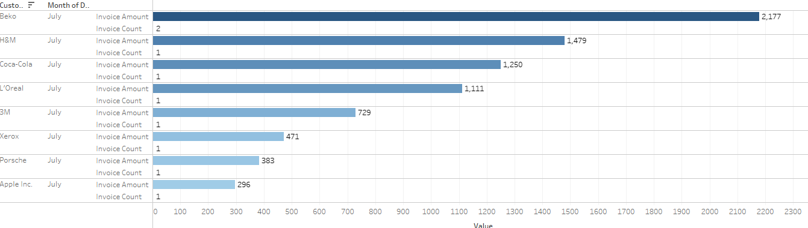

  - Reminder, Column graphs are vertical, bar graphs are horizontal
- To save your work, go to file > save as to save the file as a twbx (tableau packaged workbook) file.
  - Failure to save file as twbx will result in grade of zero
- Additional Note: Make sure you submit the twbx file
  - Do not submit the temp file or a twb file(if you do, grade will be ZERO)
- Submit the completed Tableau .twbx file via the D2L dropbox.: (You are not submitting screenshots)
  - Files submitted to the wrong dropbox will receive a grade of 0
  - Failure to follow directions will result in a grade of ZERO
- This is not a group assignment. Students should work independently.
  - Copying/plagiarism will result in a grade of 0 for all parties involved.
- Due on 03-15-2024, 11:30 p.m.
- Remember, file must be virus free. (Any assignment received containing a Virus receives a grade of 0)

