5320 Memorandum | 
To: 5320 students
From: Dr. Gary G. Berg
Date: December 2, 2025
Re: ACCT 5320 – (Chapter 10: Order-to-Cash(O2C) and Procure-to Pay(P2P))
This project is Question Set 1: Order-to-Cash from chapter 10 and Question Set 2 Procure to Pay
Required:
- Data file Question Set 1 (Ignore Part 4)
  - A basic Power BI shell has been created that has already imported the Excel data file for analysis
  - Download the Power BI shell
- Part 1
  - Complete the requirements for part one and answer all questions with supporting exhibits where applicable.
- Part 2
  - Completes the requirements for part two and answer all questions with supporting exhibits where applicable.
  - You do not need to create the Report Date and the Age Measure.
    - The Power BI shell already includes the creation of the Report Date and the Age Measure.
- Part 3
  - Completes the requirements for part three and answer all questions with supporting exhibits where applicable.
  - You do not need to create the Order-to Ship Days measure.
    - The Power BI shell already includes the creation of the Order-to Ship Days measure
- Data file Question Set 2 (Ignore Part 4)
  - A basic Power BI shell has been created that has already imported the Excel data file for analysis
  - Download the Power BI shell
- Part 1
  - Complete the requirements for part one and a KPI card that includes the Forfeited discounts and Forfeited discount ratio
  - Answer all questions with supporting exhibits where applicable.
- Part 2
  - Completes the requirements for part two
  - The days payable outstanding KPI needs to be filtered on Days payable outstanding and suppler account name
  - Answer all questions with supporting exhibits where applicable.
- Part 3
  - Completes the requirement for missing orders for part three
  - Answer all questions related to missing orders with supporting exhibits where applicable.

P2P formulas
Report Date = DATE(2020,12,31)
AP Age = DATEDIFF(MIN(Invoices_Received[Invoice_Due_Date]),[Report Date],DAY)
AP Balance = SUM(Invoices_Received[Invoice_Amount])-SUM(AP_Cash_Application[AP_Application_Amount])-SUM(AP_Adjustments[Adjustment_Amount])
Days Payable Outstanding = [AP Balance]/SUM(Purchase_Orders[Purchase_Order_Amount_Local])*365
Discounts Available (already done and included in one of the tables)
Discounts not taken (replaced by AP_Application_Amount in another table)
Forfeited Discounts = sUM(Invoices_Received[Discounts Available])-SUM(AP_Cash_Application[AP_Applied_Discounts])
Forfeited Discounts Ratio = [Forfeited Discounts]/SUM(Invoices_Received[Discounts Available])

Submission Requirements;
- Submit your Power BI file, and your word write-up file for the O2C and P2P question set to the appropriate question set drobox on D2L
- This is not a group assignment. Students should work independently.
  - Copying/plagiarism will result in a grade of 0 for all parties involved.
- Due on 12-10-2025, 11:30 p.m.
- Remember, file must be virus free. (Any assignment received containing a virus receives a grade of 0)
Gary G. Berg, PhD., CPA
East Tennessee State University
College of Business & Technology
Department of Accountancy
Box 70710
Johnson City, TN 37614
423-439-5336
423-439-5274 (fax)
bergg@mail.etsu.edu
http://bergg.etsu.edu

O2C
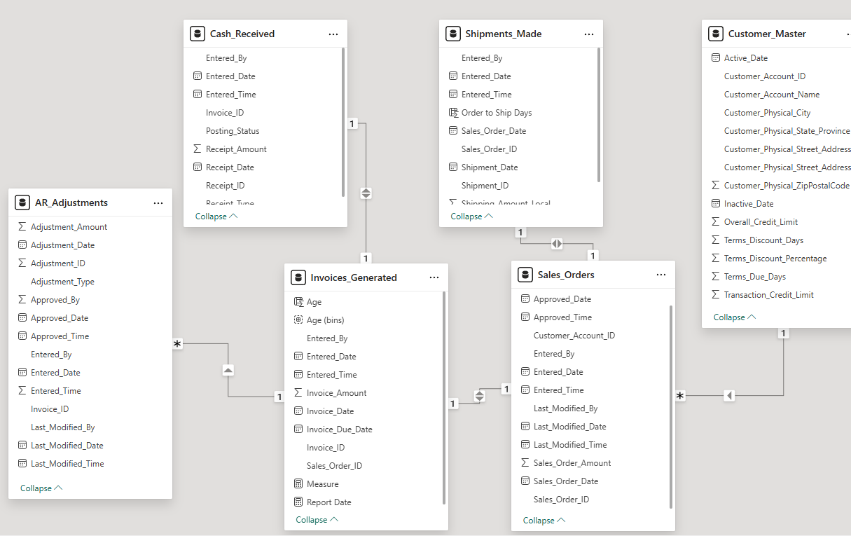

P2P
