Chapter 10 Power BI Instructions
Question Set 1: Order to Cash
- Within Power BI, import Lab 10-1 O2C Data.xlsx.
- In the Navigator, check all the Tables and click Load.
- Click Model View
  - Change the datatype for all ID fields to Text.
  - Connect AR_Adjustments to Invoices_Generated on Invoice_ID
  - Ignore User_Listing
- Click Data View and create the following measures and fields:
- Click Invoices_Generated
- Create one new column:
- Age = DATEDIFF([Report Date], Invoices_Generated[Invoice_Due_Date],DAY)
- Create four new measures:
- Report Date = DATE(2020,12,31)
- AR Balance = SUM(Invoices_Generated[Invoice_Amount])-SUM(Cash_Received[Receipt_Amount])-SUM(AR_Adjustments[Adjustment_Amount])
- Write-Off Percent = SUM(AR_Adjustments[Adjustment_Amount])/
SUM(Invoices_Generated[Invoice_Amount])
  - Days Sales Outstanding = [AR Balance]/
SUM(Invoices_Generated[Invoice_Amount])*365
  - Net Sales Revenue = SUM(Invoices_Generated[Invoice_Amount]-SUM(AR_Adjustment[Adjustment_Amount])
- Click Shipments_Made
- Create one new column:
- Order to Ship Days = DATEDIFF(Shipments_Made[Invoice_Date],
Shipments_Made[Shipment_Date],DAY)
- Return to Report View.

Part 1: Financial  - Rename Page 1 to Financial  - Create a Matrix called Sales and Receivables.  - Rows: Invoice_Date > Year and Month  - Values: Invoice_Amount, Adjustment_Amount, Net Sales Revenue, Receipt_Amount, AR Balance, Write-off Percent  - Filter Invoice_Date > Year: 2020. | 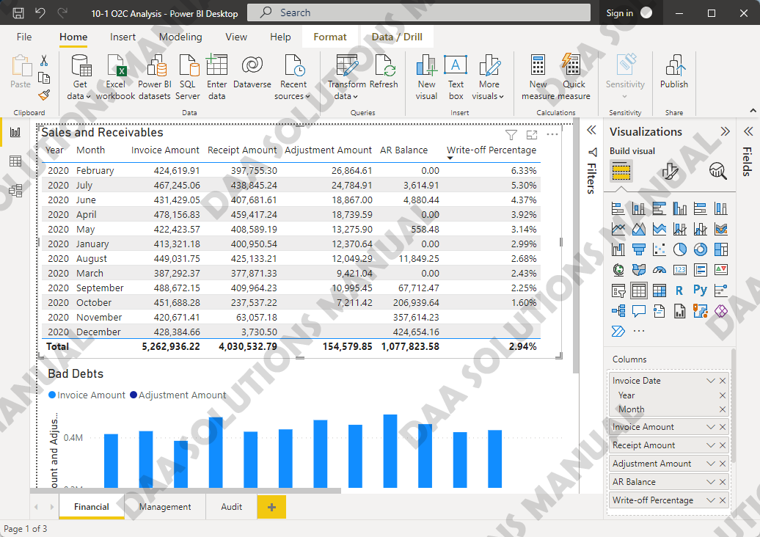
- Create a Clustered Column Chart called Bad Debts  - Y-axis: Invoice_Amount, Adjustment_Amount  - X-axis: Invoice_Date > Month  - Tooltips: Write-off percent  - Filters on this visual: Invoice_Date > Year: 2020 | 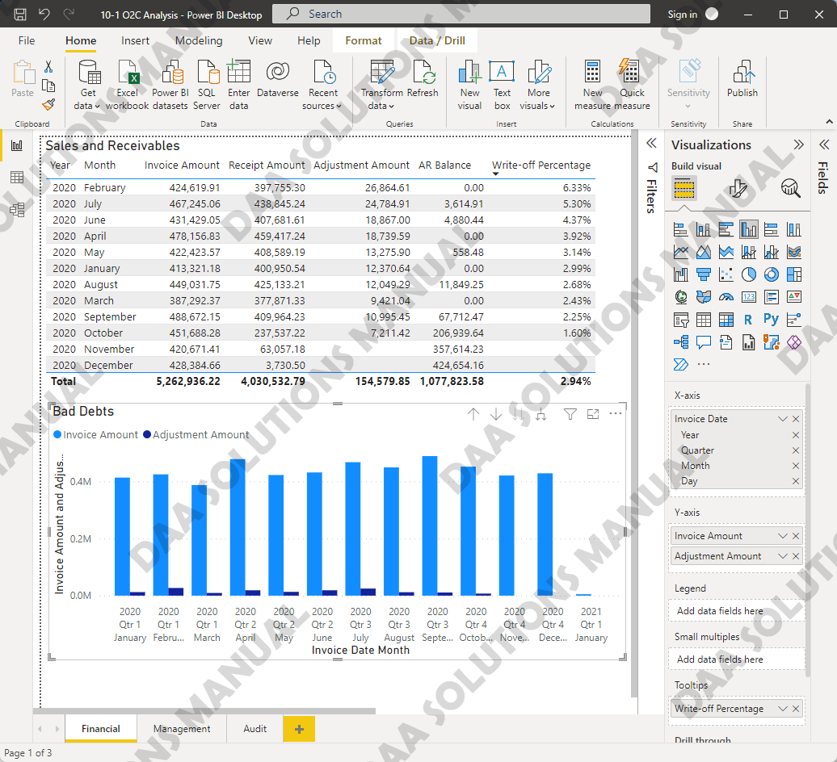
Part 2: Managerial  - Create a new Page called Managerial.  - Create a Table called Total Sales by Day.  - Filters on this visual: Invoice_Date > Month  - Columns: Invoice_Date > Day, Invoice_Amount | 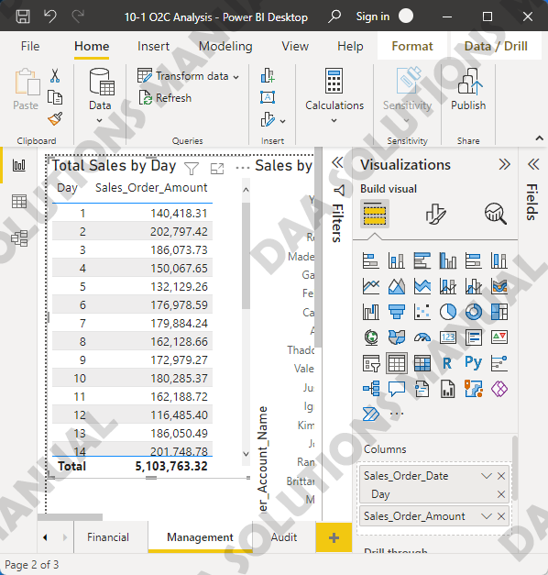
- Create a Stacked Bar Chart called Total Sales by Customer.  - Filters on this visual: Invoice_Date > Month  - Y-axis: Customer_Account_Name  - X-axis: Invoice_Amount | 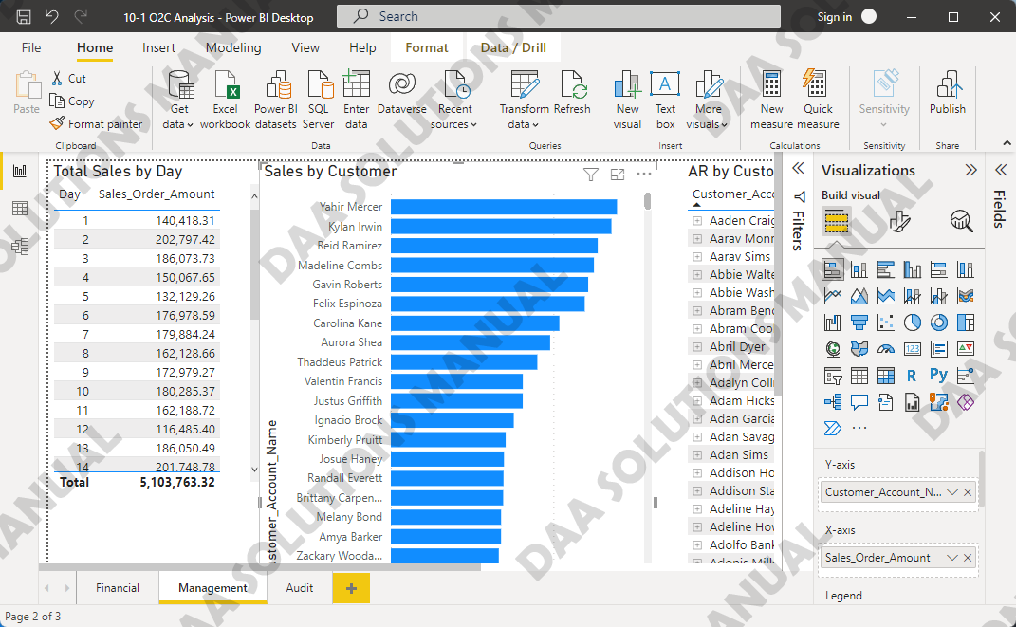
- Create a new page. Create a Matrix called AR by Customer.  - Rows: Customer_Account_Name, Invoice_ID,  - Values: Invoice_Due_Date, Age, AR Balance  - Filters on this visual: AR Balance is greater than 0 | 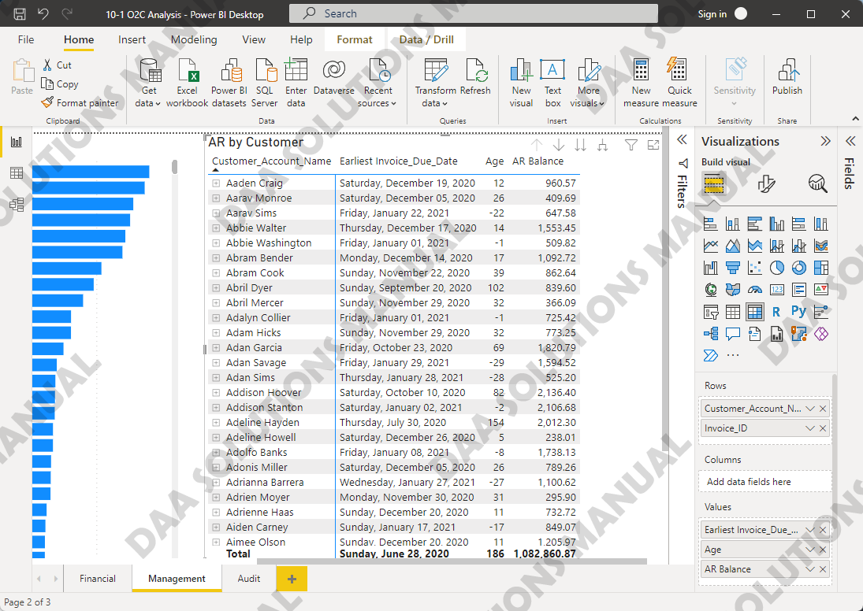
- Create a Card called Days Sales Outstanding.  - Fields: Days Sales Outstanding  - Filters on this visual: Invoice_Date: 2020 | 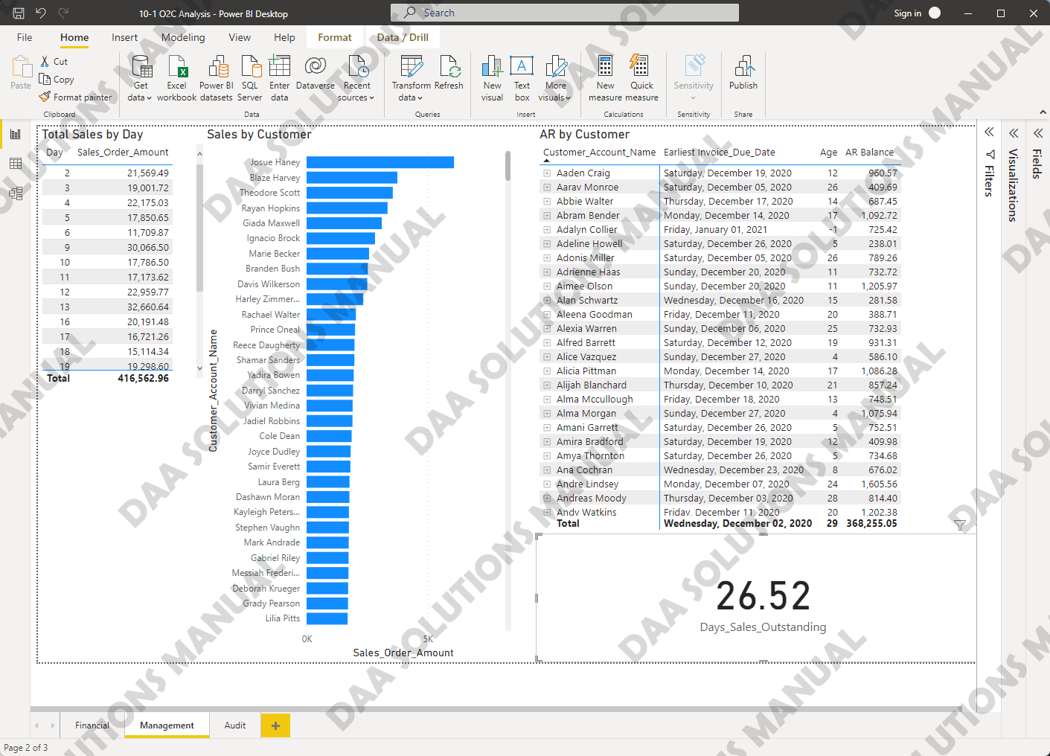
Part 3: Audit  - Create a new Page called Audit.  - Create a Table called Exceptions  - Columns: Invoice_ID, Order to Ship Days  - Sort by Order to Ship Days > Ascending | 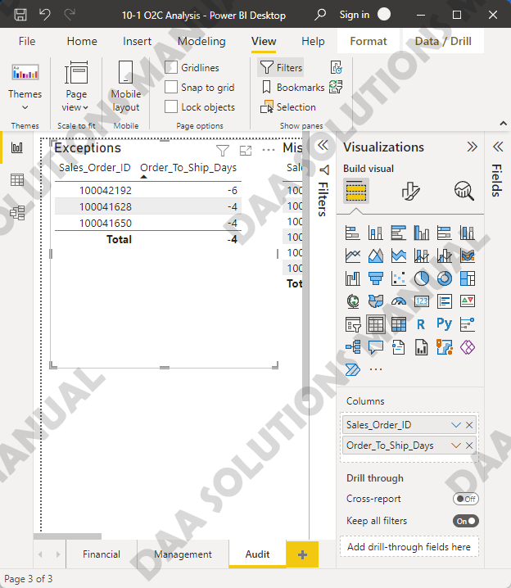
- Create a Table called No Invoice.  - Columns: Invoice_ID, Shipment_Date > Shipment_Date, Shipment_ID, Invoice_ID  - Filters on this visual: Invoice_ID is blank | 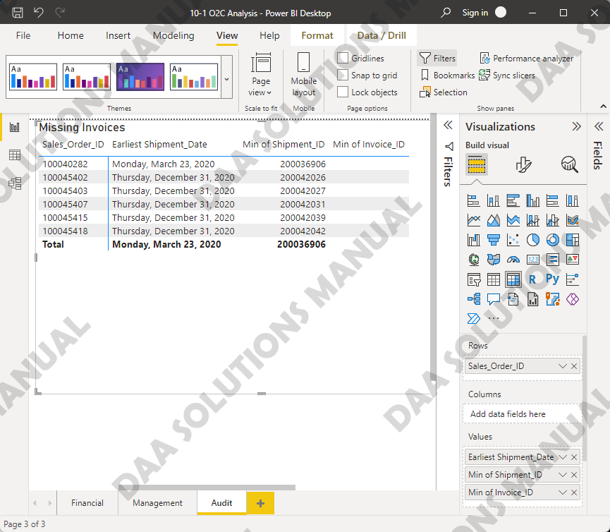
- Create a Stacked Bar Chart called Aging Report.
- Right-click Age and choose New group.
- Set bin size to 30
- Y-axis: Age [bins]
- X-axis: AR Balance

Question Set 2: Procure to Pay
- Within Power BI, import Lab 10-2 P2P Data.xlsx.
- In the Navigator, check all the Tables and click Load. Note: Adjustments table contains no values. This is expected.
- Click Model View
- Change the datatype for all ID fields to Text.
- Connect AP_Adjustments to Invoices_Received on Invoice_ID
- Ignore User_Listing
- Click Data View and create the following measures and fields:
- Click Invoices_Received
- Create two new columns:
- Age = DATEDIFF([Report Date], Invoices_Generated[Invoice_Due_Date],DAY)
- Discounts Available = Invoices_Received[Invoice_Amount]*
Invoices_Received[Terms_Discount_Percentage]
- Create three new measures:
- Report Date = DATE(2020,12,31)
- AP Balance = SUM(Invoices_Received[Invoice_Amount])-SUM(Cash_Payments[Payment_Amount])-SUM(AP_Adjustments[Adjustment_Amount])
- Days Payables Outstanding = [AP Balance]/
SUM(Purchase_Orders[Purchase_Order_Amount_Local])
*365
- Average Purchases = CALCULATE(AVERAGE(Purchase_Orders[
Purchase_Order_Amount_Local))
- Standard Deviation = CALCULATE(STDEV.P(Purchase_Orders[
Purchase_Order_Amount_Local))
- Z-Score Purchases = Purchase_Orders
[Purchase_Order_Amount_Local)-[Average Purchases]/
[Standard Deviation]

Part 1: Financial  - Rename Page 1 to Financial  - Create a Matrix called Purchases and Payables.  - Rows: Invoice_Date > Year and Month  - Values: Invoice_Amount, Receipt_Amount, Adjustment_Amount, Balance, Write-off Percent  - Filter Purchase_Order_Date > Year: 2020. | 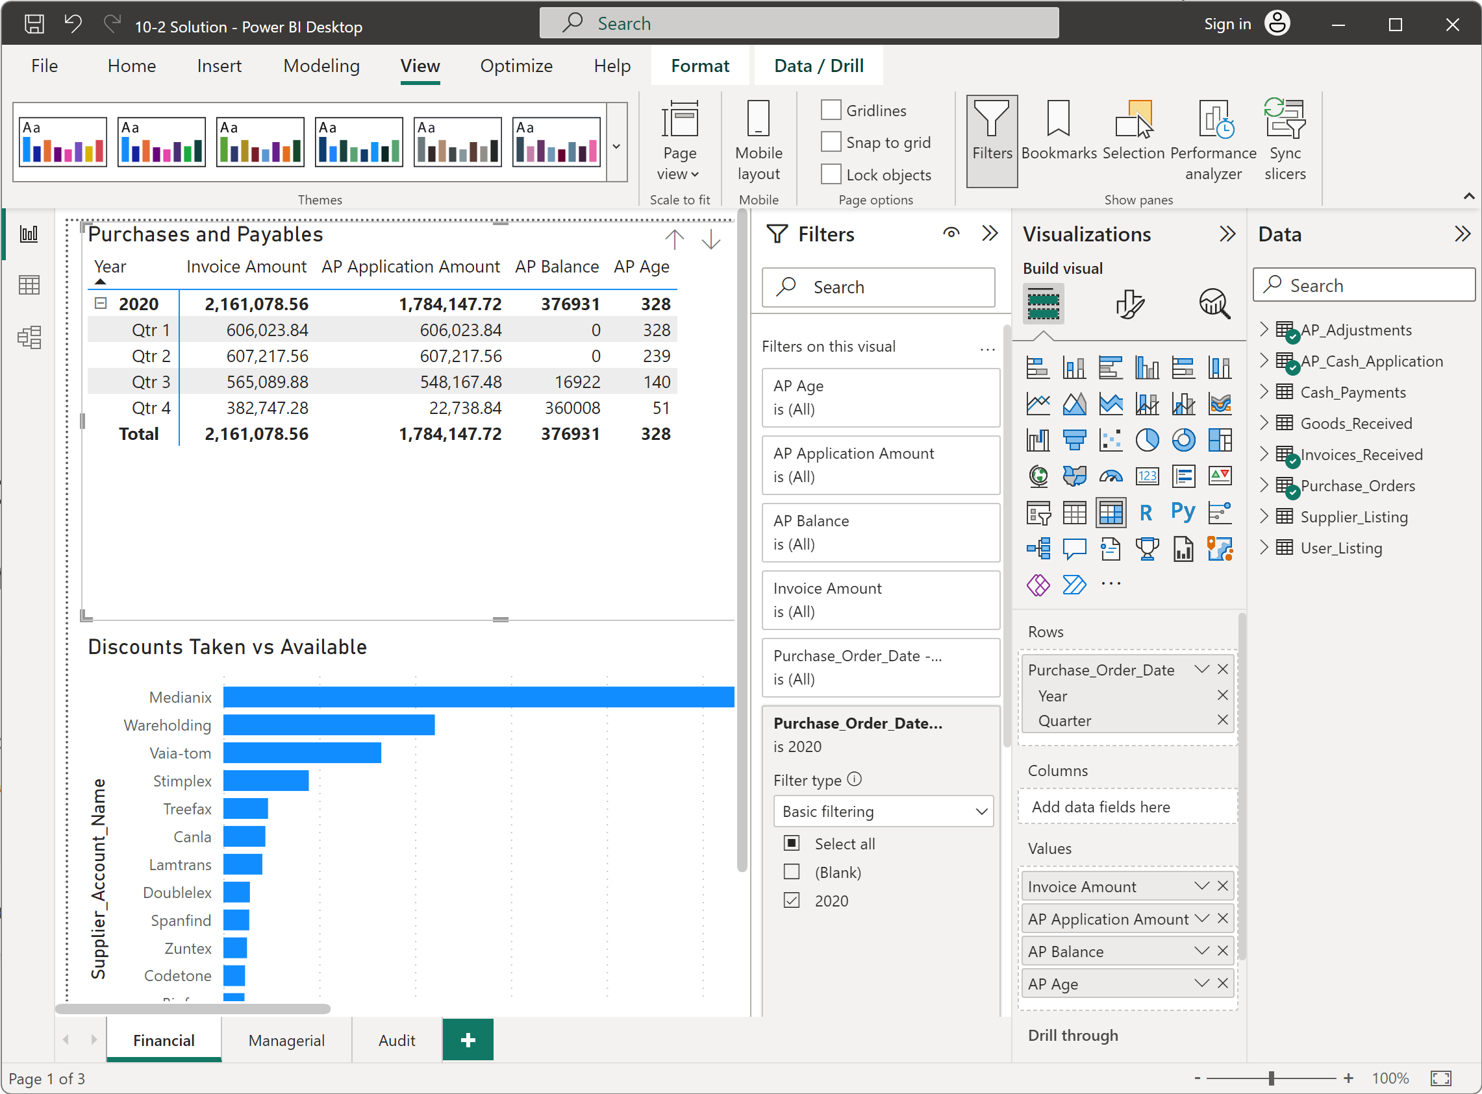
 | 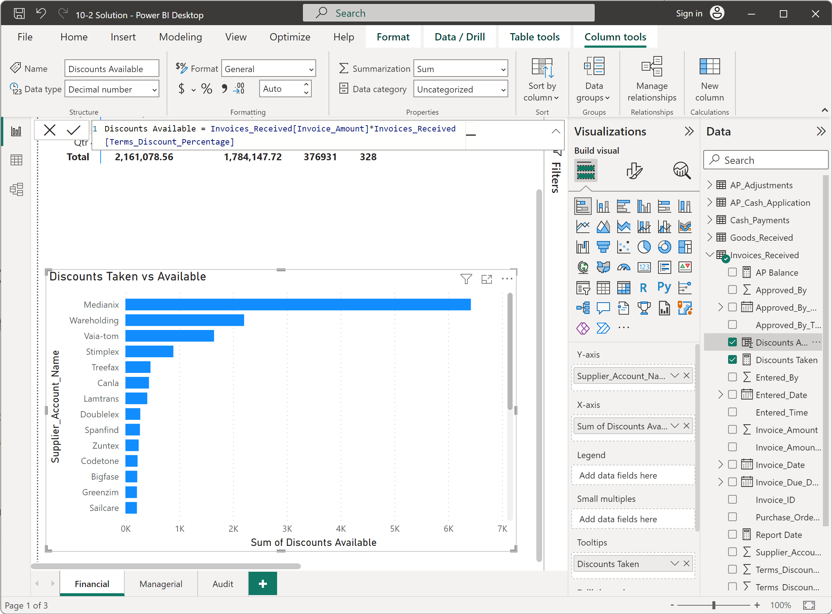
Part 2: Managerial  - Create a new Page called Managerial.  - Create a Stacked Bar Chart called Total Sales by Supplier.  - Filters on this visual: Purchase_Order_Date > Month  - Y-axis: Supplier_Account_Name  - X-axis: Purchase_Order_Amount_Local | 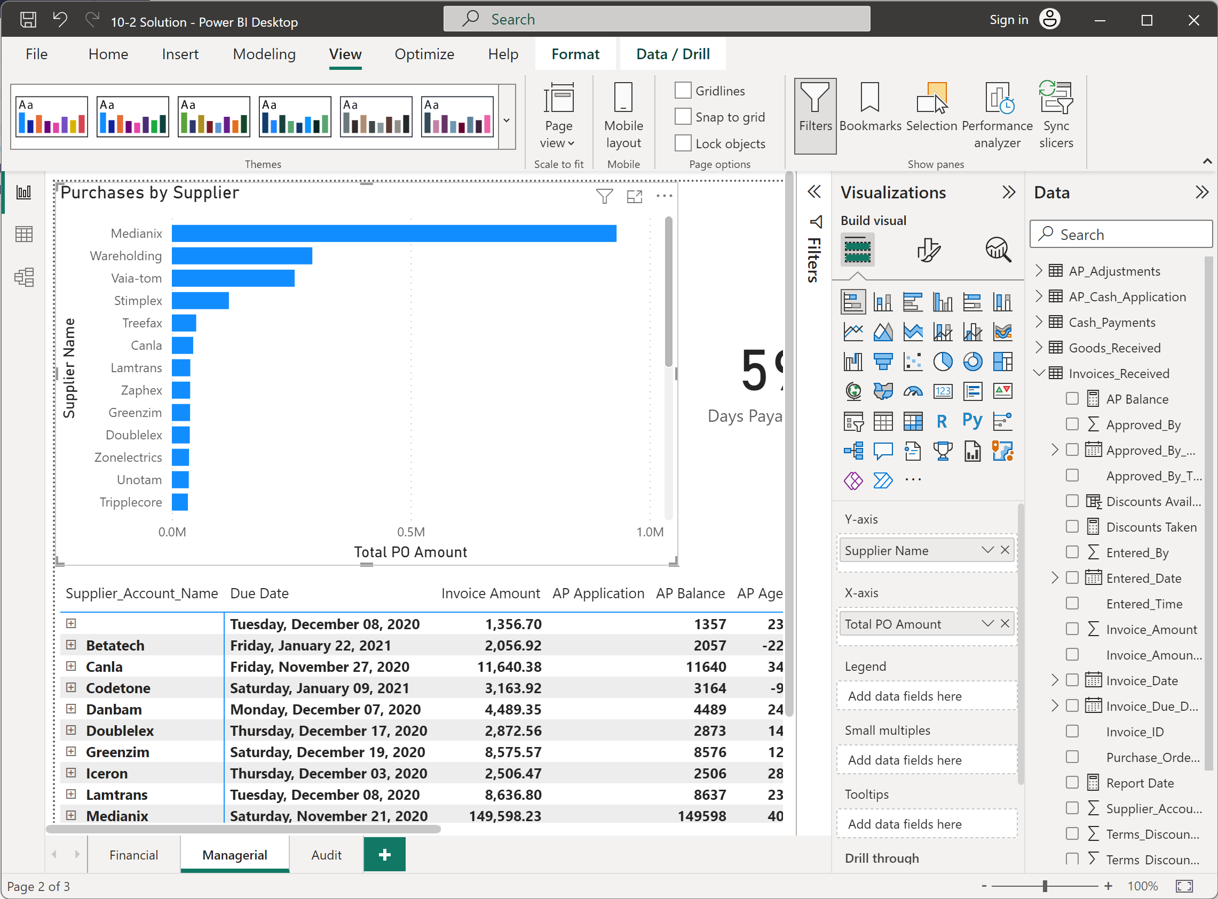
- Create a new page. Create a Matrix called AP by Customer.  - Rows: Supplier_Account_Name, Invoice_ID,  - Values: Invoice_Due_Date, Age, AP Balance  - Filters on this visual: AP Balance is greater than 0 | 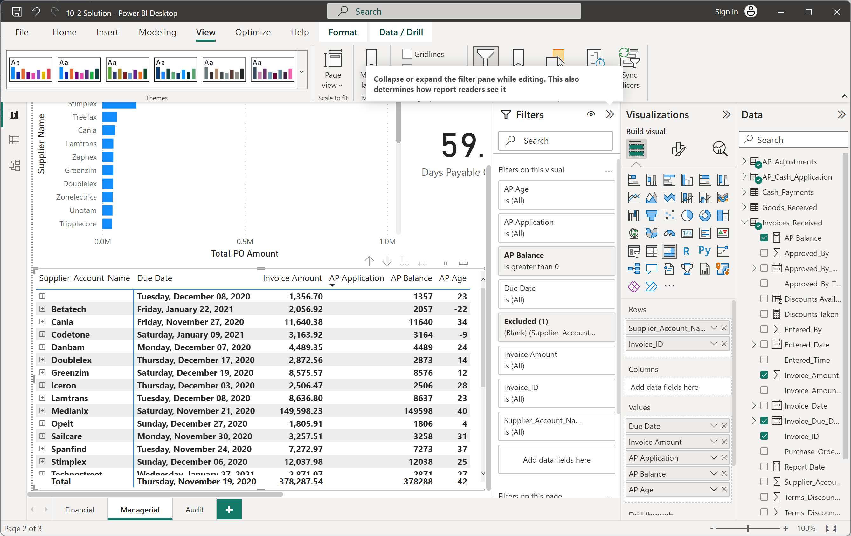
- Create a Card called Days Payable Outstanding.  - Fields: Days Payable Outstanding  - Filters on this visual: Invoice_Date: 2020 | 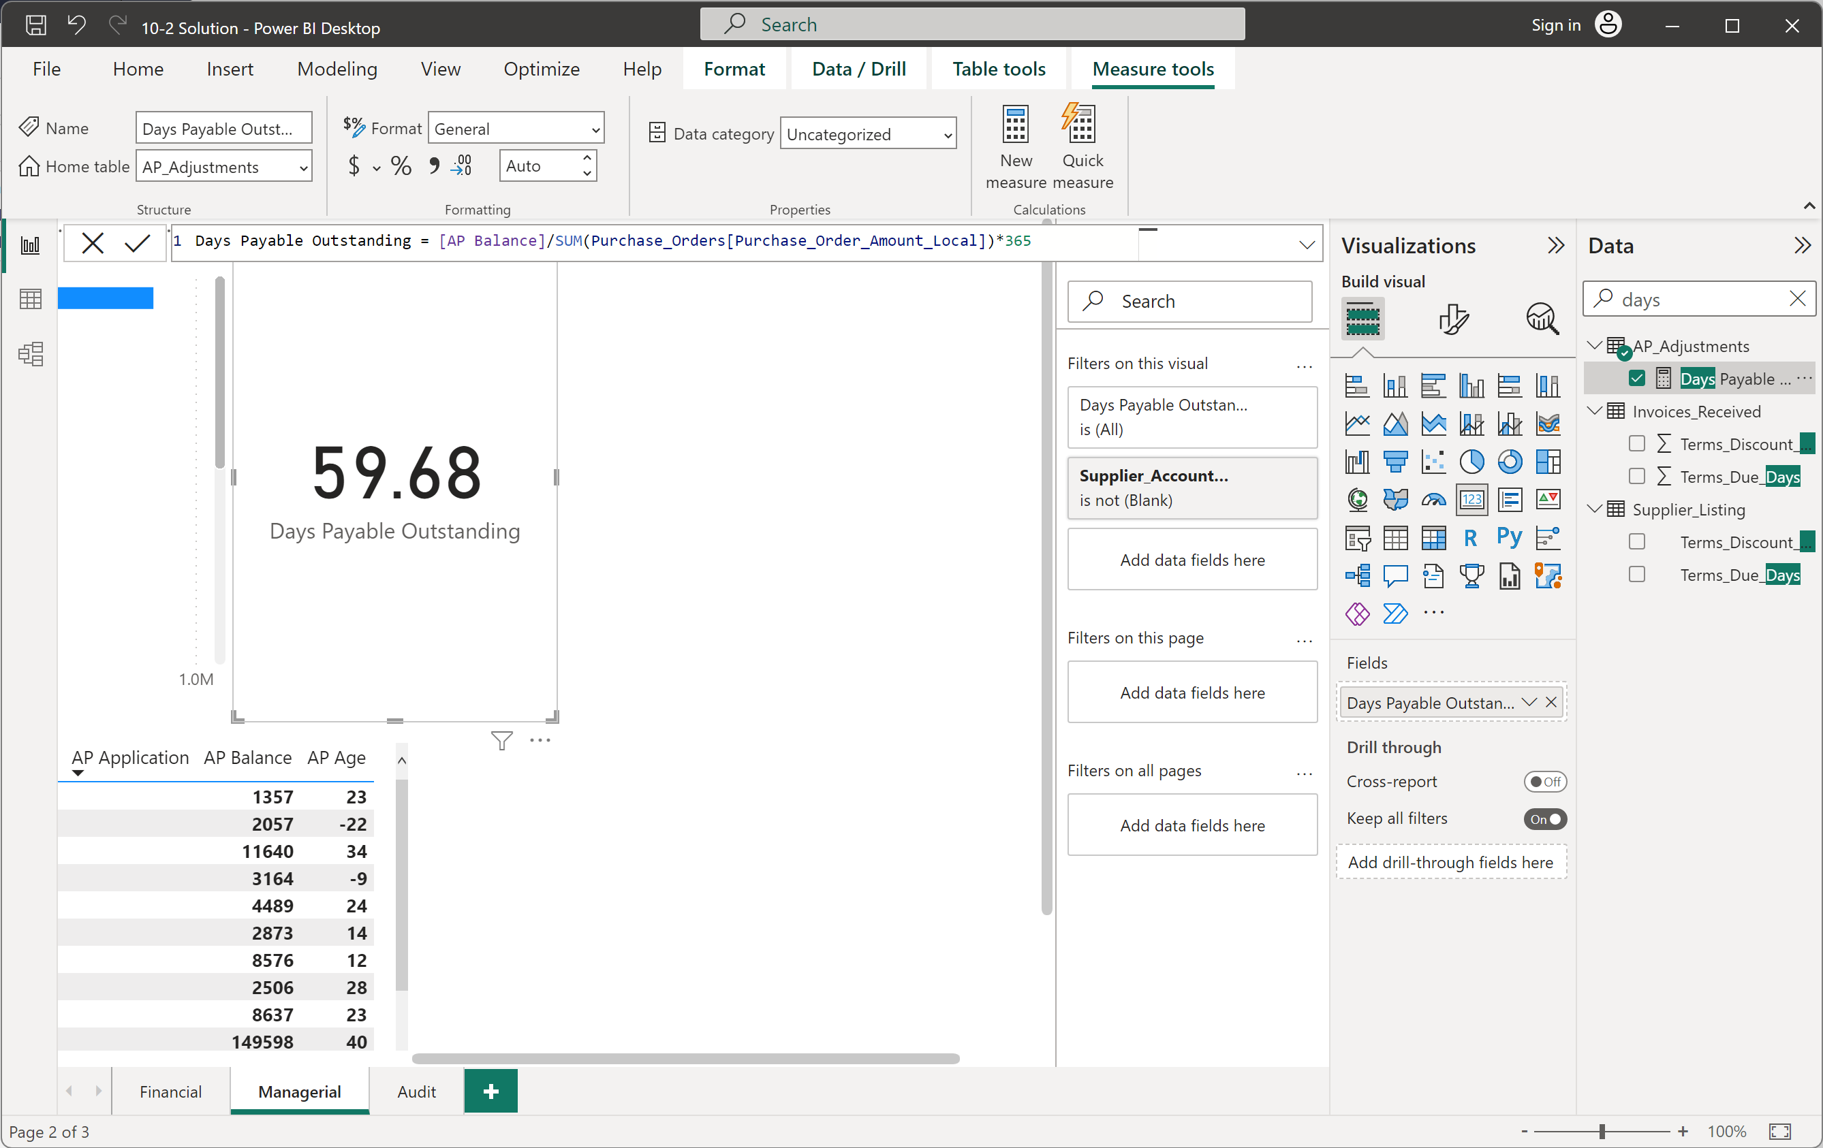
Part 3: Audit
- Create a new Page called Audit.
- Create a Stacked Bar Chart called Outliers
- Y-axis: Supplier_Account_Name
- X-axis: Z-Score Purchases
- Sort by Z-Score Purchases > Descending

- Create a Table called No Order.
- Columns: Invoice_ID, Purchase_Order_ID,
- Filters on this visual: Purchase_Order_ID is blank

