Memorandum | 
To: 4320 Students
From: Gary G. Berg
Date: March 13, 2026
Re: Assignment 9 – Tableau Joins
- This assignment is an extension of assignment 8. You will be creating crosstabs and visualizations in Tableau for the pivot tables you created in assignment 8
  - Download file for this assignment
  - You will need to create additional calculated field(s) in Tableau
- Required
  - Connect to the excel file
  - Create the necessary joins (inner joins) between the tables
    - See zoom example
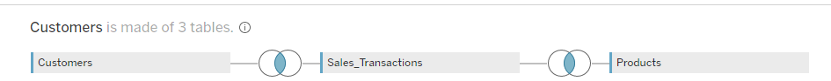
  - Create crosstabs of the pivot tables you created in assignment 8.(Make sure you Master the data)
    - Sheet 1 -Crosstab for Pivot table 1 from assignment 8
      - Name the sheet Business
      - Sort on $ sales total descending order
    - Sheet 2 - Duplicate sheet 1 to and create a bar chart and show mark labels
    - Sheet 3 - Crosstab for Pivot Table 2 from assignment 8
      - Rename the sheet Year
    - Sheet 4 - Duplicate sheet 3 to and create a bar chart and show mark labels
    - Sheet 5 - Crosstab for Pivot Table 3 from assignment 8
      - Rename the sheet product
    - Duplicate sheet 5 to and create a bar chart and show mark labels
  - Depending on your design, all crosstabs should show grand totals, subtotals and/or row totals.

- To save your work, go to file > save as to save the file as a twbx (tableau packaged workbook) file.
  - Failure to save file as twbx will result in grade of zero
- Additional Note: Make sure you submit the twbx file and not the temp file that is created when you are in Tableau
  - The temp file is erased when you exit Tableau, but there may be a delay before that happens
    - Temp files have an extension of twbr
- Submit the completed Tableau .twbx file via the D2L dropbox.: (You are not submitting screenshots)
  - Failure to submit as a twbx file will result in a grade of ZERO
  - Files submitted to the wrong dropbox will receive a grade of 0
  - Failure to follow directions will result in a grade of ZERO
- This is not a group assignment. Students should work independently.
  - Copying/plagiarism will result in a grade of 0 for all parties involved.
- Due on 03-25-2026, 11:30 p.m.
- Remember, file must be virus free. (Any assignment received containing a Virus receives a grade of 0)

